The Crucial Role of Sway Bars in Off-Road RC Cars
~ Ryno Meiring
Sway bars are integral components in off-road remote-control cars, offering indispensable benefits that elevate the driving experience. Despite their modest appearance, these bars provide essential functions that enhance stability, traction, and responsiveness on rugged terrain.
Firstly, sway bars excel in minimizing body roll during turns and sudden manoeuvres. This reduction in lateral movement is crucial for maintaining balance and preventing rollovers, ensuring a safer and more controlled driving experience, especially on unpredictable off-road surfaces. Moreover, sway bars contribute significantly to optimizing traction by evenly distributing weight across all wheels. This balanced weight distribution improves the car's ability to maintain grip, enabling it to traverse challenging obstacles and steep inclines with greater ease and efficiency. (Hawley, 2023)
Additionally, sway bars enhance the car's overall responsiveness and agility. By reducing chassis flex and promoting quicker steering inputs, they empower drivers to navigate tight corners and manoeuvre through obstacles with confidence and precision, thereby elevating the thrill of off-road driving.
Furthermore, the adjustability of sway bars allows for customization and fine-tuning of the car's handling characteristics. Enthusiasts can tailor their vehicle's performance to suit their driving style and specific terrain conditions, further enhancing the versatility and enjoyment of off-road RC car experiences. (Hawley, 2023)
In conclusion, sway bars may be small, but their impact on off-road RC car performance is immense. From enhancing stability and traction to improving responsiveness and offering customization options, sway bars are indispensable components that ensure an exhilarating and rewarding driving experience for enthusiasts.
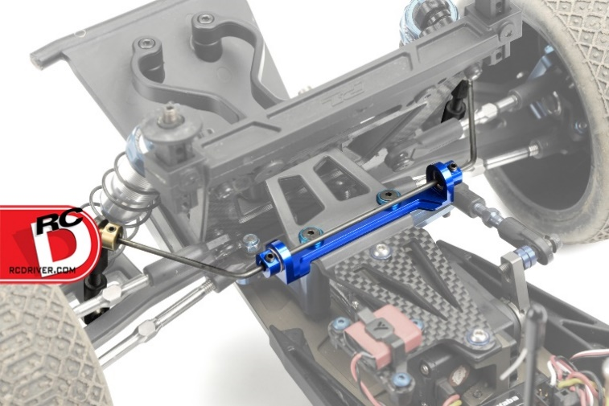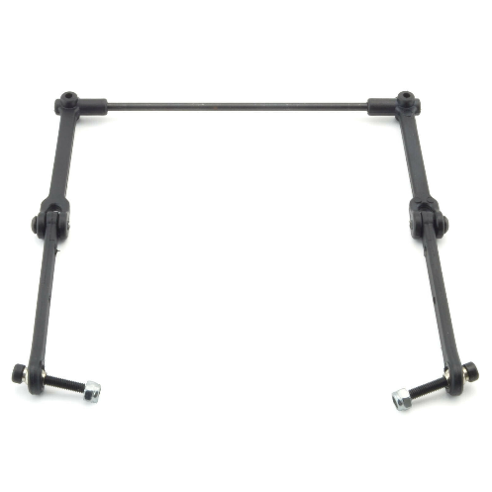

Bibliography
Hawley, D. (2023, July 20). What Does A Sway Bar Do? Retrieved from J.D. Power: https://www.jdpower.com/cars/shopping-guides/what-does-a-sway-bar-do#:~:text=The%20sway%20bar%20is%20a,improving%20handling%20and%20ride%20comfort.

